## BuzzHiveGames Sprint Completion:7/10/18

# Against the Swarm v.1(7/24/18) Sprint 1 Plan

## 

**Goal:** Get our team familiar with the technology and complete a prototype with the majority of the GUI components.

**Task Listing:**

As a player, I want to be able to retreat to a new map when the swarm destroys my last town, so that I can continue playing. 3 points

* Function that generates new set of towns

30 min (random positions) Zeyuan Jiang

* Save the existing towns for eventual return

15 min (might need a new storage object) Zeyuan Jiang

* Set the current array of towns to the new array of towns

15 min Zeyuan Jiang

* Reset the Invasion Progress

15 min Zeyuan Jiang

* Set the player’s current position to the town closest to the swarm (4)

15 min Zeyuan Jiang

* Trigger this when invasion progress >= 100

15min Zeyuan Jiang

As a player, I want to be able to gain Follower Resource by protecting refugees as they flee the swarm. 2 points

* Create global variable for Follower Resource (game_logic.js)

15 min Jolene Nguyen

* Create function that increments this that takes in current towns (more undestroyed towns more resource)

30 min Jolene Nguyen

* Put above function in main loop in index.html (line 22)

15 min Jolene Nguyen

As a player, I want to be able to view a list of items from monsters and the amount of follower resource I have so that I can make decisions about what followers to hire. 2 Points

* Create User Inventory object {meat, scale, claws, fiber, metal, gelatin}

With increment/decrement functions/get/set

30 min Buzz Tilford

* Create table-like display object in html and that shows these six items in 2 differentiable containers

30 min Buzz Tilford

* Add updates to gui.js to update these values

30 min Buzz Tilford

* Create display object for Follower Resource in followers container

30 min Andrew Kim

* Add update to gui.js to update the Follower Resource value(found in game_logic.js)
* 30 min Zeyuan Jiang

As a player, I want to see technologies available and that I’ve purchased, so I know my status. 5 Points

* Implement Technology object

1 hour Brandon Pham

* Array of technology (3 { enough to test the GUI } )

45 min Brandom Pham

* Basic UI that shows list of available and bought technologies

1 hour Brandom Pham

As a designer, I want the invasion rate to go up if there are more enemies, so that the player has to keep fighting faster. 2 Points

* Change enemy to array of enemies (with one enemy for now)

30 min Jacob Swanson

* Make sure the player can still kill the enemy and it respawn

45 min Jacob Swanson

* Have a function which counts the number of enemies

15 min Jacob Swanson

* Create invasion rate variable in game_logic.js

15 min Jacob Swanson

* Make a function that check the enemies and increase rate and increases invasion progress

30 min Jacob Swanson

(2) As a player, I want to be able to shift the camera focus between the town and battlefield

* Camera panning during engage/disengage. 2.5 hours Buzz Tilford

(3) As a player, I want to be able to hire followers with a Follower Resource so that I can fight the swarm more effectively, process items, research technology, and mine crystals to send myself, my followers, and refugees into a safer realm.

* Implement Follower.js to include 3 Processors, Fighters, Miners, Researchers, Teleporters 1.5hours Andrew Kim

(8) As both a player and as a designer, I want a group of combatants to be able to fight another group of combatants, so that combat is more interesting.

* Create new fighter.js object.

15 min Zeyuan Jiang

* Replace the player with array of fighters.

1 hour Zeyuan Jiang

* Replace the monster with array of monsters.

1 hour Zeyuan Jiang

* On hover on the monster, show the monster’s information including health bar.

2 hours Zeyuan Jiang

* Create a function that spawns monsters over time.

30 min Zeyuan Jiang

* Update the game logic functions (fight, disengage, rest) function in the game_logic.js to take into account multiple fighters and enemies. 2 hours Zeyuan Jiang

(1) As a player I want to have new item system, so I can can see how much of each item I have and can gain advanced items

* As a user I want to know how much of each items I have and I want raw goods to be convert to finished goods over if I have the correct followers

15 min Buzz Tilford

(3) As a player I want a tree of technologies so that I can increase the power of followers

* + Design the technologies for implementation

1 hour Buzz Tilford

(5) As a player, I want to be able to reclaim towns, so that I can eventually fight the swarm back to its home realm, kill it, and win the game.

* Create button to reclaim towns, this button is enabled when you push the invasion progress variable beyond a destroyed town.

15 min Jolene Nguyen

* When you click the reclaimed towns button, the game shifts into a “reclaim mode” the game’s timers are stopped until you disengage or kill all of the enemies.

1 hour Jolene Nguyen

* Disable enemy respawning in “reclaim mode”

15 min Jolene Nguyen

* Set reclaimed town as players current location and re-enable timer, push invasion progress back by 10

15 min Jolene Nguyen

**Team Roles:**  
Buzz Tilford: Product Owner

Zeyuan Jiang: Scrum Master

Andrew Kim: Developer, Artist

Jolene Nguyen: Developer

Brandon Pham: Developer

Jacob Swanson: Developer

**Initial Task Assignment:**

Buzz Tilford: As a player, I want to be able to view a list of items from monsters .

Zeyuan Jiang: As a player, I want to be able to retreat to a new map when the swarm destroys my las

Andrew Kim: As a player, I want to be able to view how much Follower Resource I have so that I can make decisions about what followers to hire.

Jolene Nguyen: As a player, I want to be able to gain Follower Resource by protecting refugees as they flee the swarm.

Brandon Pham: As a player, I want to see technologies available and that I’ve purchased, so I know my status.

Jacob Swanson: As a designer, I want the invasion rate to go up if there are more enemies, so that the player has to keep fighting faster.

**Initial Burn Up Chart:**

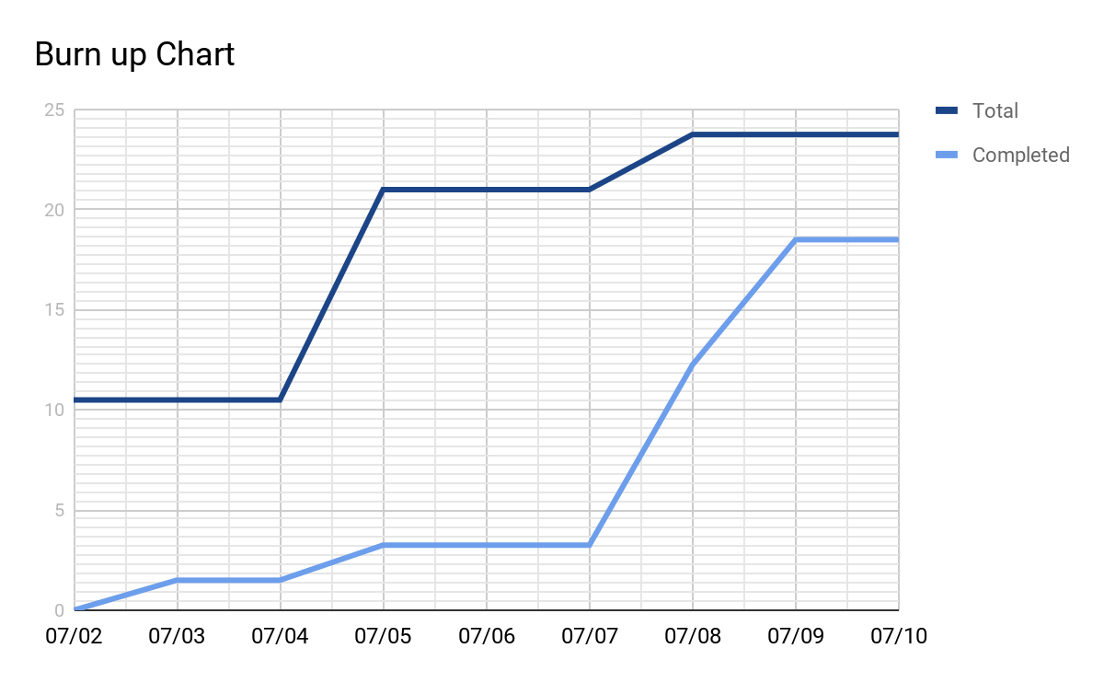

**Initial Scrum Times:**

Tues 12:00 PM with TA

Thur 5:30 PM with TA  
 Sun 1:00 PM(placeholder time)